Assignment 2 Digital and Analog Input & Output

Released Date: September 26th

Version 1.0

Format: Name the document in the combination of name、ID and No. of Assignment.

**Example: Ping Yi_30802023_Assignment2.doc**

**Email the document to “pingy@wxit.edu.cn” before Oct 1st.**

**Font’s requirement:**

**Chinese Letter “宋体五号”**

**English and digit Letter “Time New Roman 五号”**

**Task 1** Specify and mark **Arduino Uno onboard Digital and Analog Pins.**

任务1 描述和标注Arduino Uno板上的数字引脚和模拟引脚。

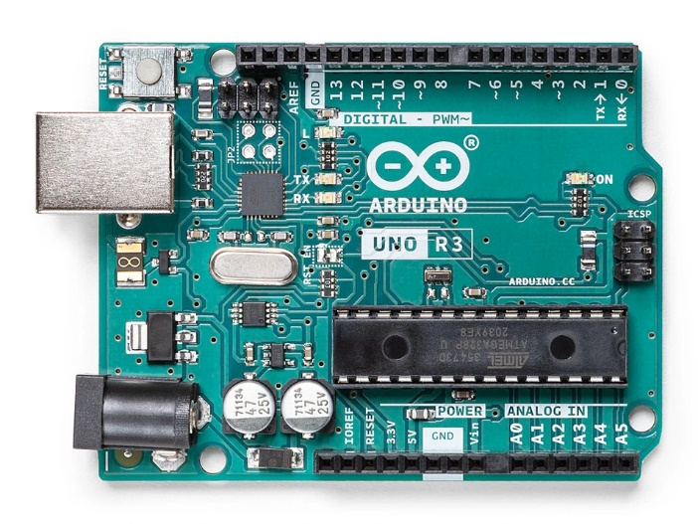

Fig 2 Arduino Uno Board

**Task 2 One** LED is linked with the **digital pin**, set up a circuit to use **a button (or two)** to control the on and off state of the LED. Draw the circuit in TinkerCAD, make the executable codes for the function

任务2 一个LED与数字引脚相连，设置一个电路，用一个（或两个）按钮来控制LED的开启和关闭状态。在TinkerCAD中绘制电路，编写功能的可执行代码。

Fig 2 Circuit

Task1

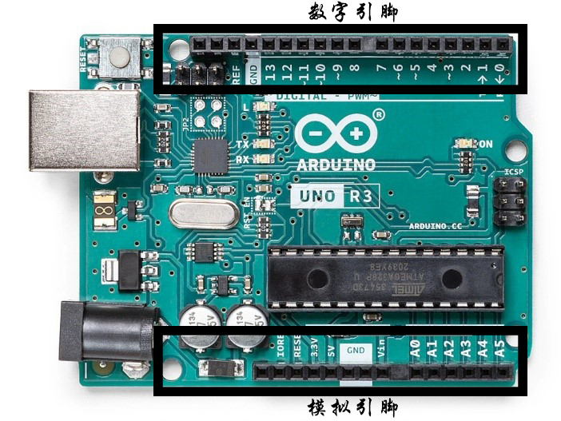

Task2

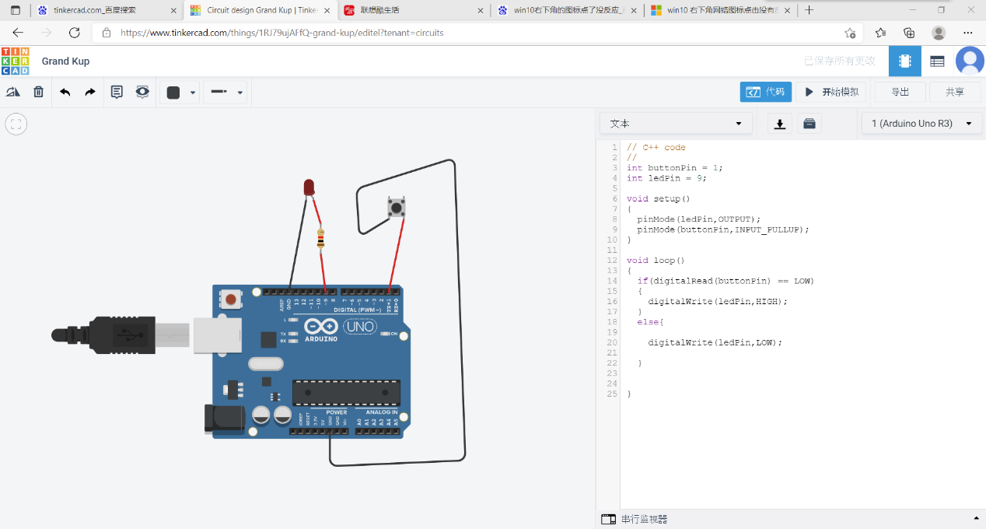

// C++ code

//

int buttonPin **=** 1**;**

int ledPin **=** 9**;**

void setup**()**

**{**

pinMode**(**ledPin**,**OUTPUT**);**

pinMode**(**buttonPin**,**INPUT_PULLUP**);**

**}**

void loop**()**

**{**

**if(**digitalRead**(**buttonPin**)** **==** LOW**)**

**{**

digitalWrite**(**ledPin**,**HIGH**);**

**}**

**else{**

digitalWrite**(**ledPin**,**LOW**);**

**}**

**}**